# Exploring characteristic features in gait patterns for predicting multiple sclerosis. (<https://ieeexplore.ieee.org/stamp/stamp.jsp?tp=&arnumber=8857604>)

* Looked at gait analysis
* Previous findings
  + MS
    - Reduced stride length
    - 2x gait variability
    - Slower walking speed
    - Increased self rated fatigue
* Experimental setup
  + Participants walked on treadmill at comfortable pace for 90s
  + Treadmill force sensors used to collect data
* Results
  + 18% reduction in step length
  + 20% reduction in gait speed (not statistically significant, p = 0.06)
  + Step width, stride time, single support time had no significant differences
  + Footsteps divided into light, average, heavy categories
  + MS patients had higher proportion of light steps and lower proportion of heavy steps
* Main takeaways
  + Horizontal displacement, proportion of light/heavy steps are possible features

# Wearable Sensor Technologies to Assess Motor Functions in People With Multiple Sclerosis: Systematic Scoping Review and Perspective

(<https://www.jmir.org/2023/1/e44428/>)

* Accelerometers were most common type of sensor
* Functional domains measured
  + Functional domain of physical activity
  + Gait
  + dexterity/tremor
  + Balance
* Paper doesn’t seem to mention specific features

# Body-worn motion sensors detect balance and gait deficits in people with multiple sclerosis who have normal walking speed

(<https://www.sciencedirect.com/science/article/pii/S0966636211007946>)

* Gait and balanced are measured subjectively currently - not good
* Timed 25 foot walk - easy to use, 20% change required to be significant, low sensitivity
* Experimental setup
  + Tasks
    - Timed 25 foot walk - walk 25 feet as fast and as safely as possible
    - Timed up and go - get up from chair, walk 7 feet, then return to chair as quickly as possible
* Sensor locations: ankle, wrist, upper trunk, lumbar trunk
* Wrist sensors Xsens
  + Located on dorsum
  + Measured
  + Arm swing peak speed degrees/s p = 0.57
  + Arm swing swing variability % p = 0.6
  + Arm swing range of motion degrees p = 0.76
* Angular trunk range of motion significantly larger in MS than controls

# Accelerometry Reveals Differences in Gait Variability Between Patients with Multiple Sclerosis and Healthy Controls

(<https://link.springer.com/article/10.1007/s10439-012-0697-y>)

* Previous research
  + Sosnoff et al
    - Greater variability in time between steps
    - More variability in single support percent differences
    - More variability in step width
* This study aimed to measure the above factors with upper body sensors
* Experimental setup
  + 100 ft straight walk down hallway
  + 6 sensors
    - Sternum, posterior trunk, left/right wrist, right/left lower shank
    - sternum/lumbar sensors for trunk motion
    - Shank sensors for stride
  + Findings
    - MedioLateral frequency dispersion greater than controls, AnteroPosterior RMS was lower than in controls for trunk
    - Acceleration of trunk had greater divergence (LyE?) in both ML and AP
    - No difference in stride velocity
  + 80% of PwMS report problems with spasticity
    - Velocity dependent increased tonic stretch, exaggerated tendon jerks, might explain greater ML divergence

# Physical Activity Recognition of Elderly People and People with Parkinson’s (PwP) during Standard Mobility Tests using Wearable Sensors

(<https://ieeexplore.ieee.org/stamp/stamp.jsp?arnumber=8090858&tag=1>)

* Goal was to use ML trained on accelerometer data to identify different activities
  + Done with parkinson’s data
* Selected features, individual and concurrent
  + Mean, Autocorrelation, Power Spectral Density, Spectral power, entropy,
  + 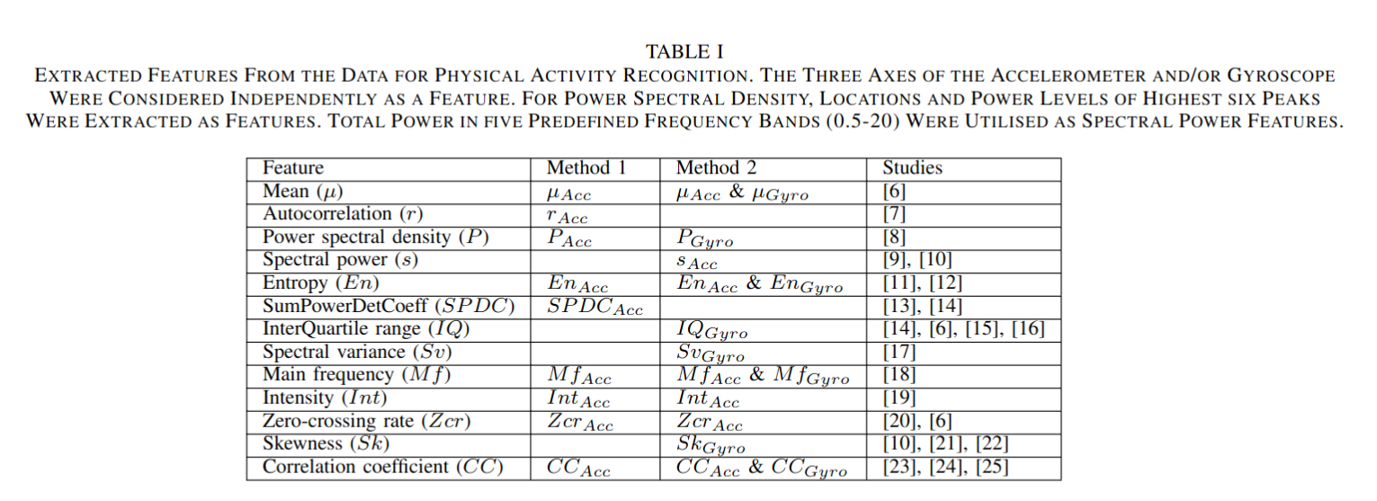
* Conclusions
  + Using gyroscope + accelerometer increases accuracy
  + LogitBoost has highest accuracy

# Postural Response Latencies Are Related to Balance Control During Standing and Walking in Patients With Multiple Sclerosis

<https://www.sciencedirect.com/science/article/pii/S0003999314000276>

* Looked at postural response latencies in relation to balance dysfunction during standing and walking
* Experimental setup
  + “translating platform” 4cm/sec
    - Requires participants to move to stay balanced without stepping
    - Measured response time from platform moving to activation in tibialis anterior (lower leg muscle)
  + Walking
    - Sensors located on sternum, trunk, lumbar, wrists
    - Features examined
      * Trunk pitch, yaw, roll range of motion + standard deviations
      * Mean peak horizontal and sagittal (front to back?) velocity
      * SD of peak horizontal and angular velocity
* Unsure how these features were taken from wrist accelerometers

# Use of wrist-worn accelerometers to quantify bilateral upper limb activity and asymmetry under free-living conditions in people with multiple sclerosis

(<https://www.sciencedirect.com/science/article/pii/S2211034821003485>)

* Wrist worn triaxial accelerometers for 2 days in free living conditions
* Integrated dominance as a factor
* Experimental setup
  + Box and Block test(?) for dexterity
  + 2 days of normal daily activities, sensors worn 24/7 except for water based activities
* Triaxial data was converted into resultant vector
  + Features
    - Sum of resultant vector (VM) for each limb - bilateral magnitude
    - Minutes of use - time VM is > 0
    - Use ratio - ratio of time of VM>0 between sides, ignores intensity
    - Magnitude ratio - natural log of VM counts
    - Mono arm use index - sum of magnitude of independent movements (only one arm active) for each arm, can quantify frequency frequency of independent movement in activities
    - Bilateral arm use index - same as mono arm use index but with both arms active
* Results
  + Asymmetry
  + Reduced upper limb activity
  + Dominant hand used more often in MS than unaffected people
  + Dominant hand provides more force when both arms are active